**Active Duty Service as the Ultimate Intercept for Diversion of Veterans from Incarceration and Recidivism in the Civilian Criminal Justice System**

by

Evan R. Seamone[1]*

1. **Introduction**

The tolls of recent sustained combat operations are increasingly evident in civilian courts as judges across the nation are seeing greater numbers of active duty, reserve component, and discharged veterans with acute legal problems. Whether the courts are dealing with child support arrearages, divorce and child custody, or criminal offenses, judges in each legal forum are encountering special difficulties in adjudicating cases. New and complex issues like discharge characterization, VA benefit eligibility, “invisible wounds of war” from combat and other military operations, deployment cycles, and blended military families with children from different marriages have created serious concerns about the courts’ capacity to effectively address the special concerns of military members and veterans. Retired New York Family Court Judge Janice Rosa, who created the first specialty family court docket for military families, made a common observation that reaches across the courts:

Where at one time a judge might preside rarely or occasionally over a civil case involving active or retired military, since 9/11 and nonstop military fronts those numbers have increased like a rising tide, silently but inexorably. Much like the slowing heating water in the lobster pot, we in the court system did not consider them any more than anomalies until their numbers and the presenting problems were daily.

(Rosa, 2013). The growing need for differentiated system-wide responses to military members and veterans largely finds its origin in the realization that common aspects of military culture, which help to condition warriors and make them effective in combat operations, also create tremendous deficits in help-seeking behavior that perpetuate and aggravate common and destructive symptoms of mental health disorders. In other words, there is no immediate “off switch” to recondition veterans for civilian life after their service concludes. At base, the civilian court system has begun to make monumental shifts to accommodate military and veteran-affiliated parties’ needs for treatment and to continued reintegration into civilian society after significant time enmeshed in the military culture.

The most significant and widespread deviations from standardized judicial approaches have occurred in the criminal justice system. Public agencies have restructured their procedures for identifying and responding to military and veteran-affiliated offenders from the point of initial interaction with law enforcement personnel through arrest and booking, to court appearances, sentencing, detention and incarceration, and even reentry back into the civilian community after confinement. Although family courts, domestic violence courts, and others in the civil system are exploring options to better serve veteran and military affiliates, the criminal justice system’s more aggressive response is explained by two underlying reasons. First, although not always explicit, the genesis of military- and veteran-specific Crisis Intervention Approaches, Veterans Treatment Courts (VTCs), and other methods for diverting offenders from incarceration to treatment is the recognition that certain types of criminal offending—particularly violent offending—are often byproducts of predictable mental health conditions that originate from the innocent and admirable fact of performing one’s military duties. This is most clear in many VTC charters that condition participation in such programs on the existence of combat related mental health conditions that *originated during service in the military*.

Second, similarly implicit in the motivation for developing military- and veteran-specific interventions in the criminal justice system is recognition of the need to mitigate tremendous risks that are associated with a traditional punitive approach. This mitigation mindset is evident in the growing numbers of specialized veterans housing units in prisons and jails that group veterans together in separate therapeutic environments that emphasize the pride of their prior service and avoid factors that can aggravate symptoms of their military-derived mental health conditions. In Kennebec County, Maine, for example, the “Vet Block” in the county jail features manual doors that have been disabled to avoid the rapid-fire sounds of the automatic locking system that are nearly indistinguishable from machinegun fire (*A Matter of Duty*, 2013). The goal there is to limit reminders of combat trauma that could aggravate detainees’ Posttraumatic Stress Disorder (PTSD) symptoms. In Arizona, Sheriff Joe Arpaio, widely known to be America’s toughest and least sympathetic jailer, recently summarized an innovative policy change that has influenced at least seventeen prison or jail facilities to date: “This program is our way of letting you know that we have not forgotten your commitment, despite whatever circumstances in your life have landed you in the custody of the Maricopa County Sheriff’s Office” (ABC News Radio, 2013). In sum, civilian justice institutions’ collective mission to address the special needs of military and veteran affiliates recognizes that, for a significant portion of military members who have or are transitioning back to civilian society, criminal offending is a *frequent component* of their reintegration experience, and, moreover, one that simultaneously represents symptoms of mental health conditions.

This paper uses the theoretical framework of Munetz and Griffin’s Sequential Intercept Model (2006) to analyze and evaluate military- and veteran-specific interventions within the criminal justice system. The Model exists as a method to avoid the criminalization of mental illness by identifying “intercept” points along the predictable spectrum of justice involvement where public services and law enforcement can use community resources to divert offenders into treatment. In more recent years, legal scholars have explored the ultimate aim of such interventions as “*de*carceration”—the converse of incarceration, which emphasizes recovery and avoids the deleterious aspects of mass incarceration on persons with mental illness (McLoed, 2012). Before discussing the foremost veteran-specific intercepts adopted by the civilian criminal justice system, **Part II** explores the bases for such involvement, i.e., the myriad ways in which military and veteran affiliates engage in criminal behavior as a result of prior military service. Although the overwhelming majority of military members and combat veterans are *not* afflicted with mental health disorders and do *not* engage in violent or criminal behavior, some inevitably do. Among the members of this small, but hardly insignificant, group, much of the behavior stems from predicable and unavoidable occupational hazards of loyal and faithful service.

After describing the common service-related pathways to symptomatic offending, **Part III** discusses the foremost intercepts adopted by the Department of Veterans Affairs (VA) and other public agencies that collectively represent civilian society’s recognition of a fundamental role in the post-military reintegration process for the civilian criminal justice system. Although some critics, like retired Connecticut Supreme Court Justice Barry Schaller, would seek to shift all responsibility to the military for solving mental health problems with military mental health and disciplinary structures while troops are still serving (2012), inevitably, many of the most prominent mental health challenges emerge only after separation from the Service after it is too late to draw from abundant and specialized care for actively serving troops. This Part identifies how the increasing volume of military and veteran offenders in civilian society has prompted specialized services in recognition of a public health and public safety mandate to protect law enforcement, future victims, the veterans’ families, and society at large. These specific changes must be distinguished from, and are not simply attributable to, common altruistic themes of “thanking veterans for their service” or showing sympathy for their plight (Seamone, 2013).

Finally, **Part IV** expands on the current conception of the Sequential Intercept Model and concludes by recognizing the need for an entirely new initial intercept that has special value for veteran- and military-specific criminal justice interventions. It is widely theorized that the most pivotal intercept point is the time when police make first contact with veterans and military members *prior to arrest*, when they can divert those offenders into community treatment facilities without beginning a booking process that would carry discretion over to prosecuting attorneys, judges, or other authorities (Munetz & Griffin, 2006). While this is quite true for civilian offenders, actively serving members of the military or reserve components who have not yet been discharged are caught up in a separate military system with totally different lines of authority and special procedures. In short, this Part places the initial—and most vital—intercept at any stage of involvement *prior to the discharge* of the service member, specifically because a negative discharge characterization has significant impacts on an individual, the brunt of which disproportionally fall on civilian society. In other words, when a service member is discharged in a less-than-honorable manner based on misconduct related to mental health conditions, the impact on the military is minimal. In fact, swift ejection of the offender gains the military another spot for a new mission-capable recruit. However, significant hardships follow the ex-service member in society for generations, ultimately affecting family members and society at large.

This Part recognizes the vital importance of diversion opportunities along the spectrum of *military justice involvement*, and the extension of the Sequential Intercept Model into military service prior to discharge. Through coordinated involvement in stages prior to discharge, the civilian criminal justice system can best mitigate significant future risks of recidivism, public health expenditures, and intergenerational effects on immediate family members (Seamone, 2013; Seamone et al., 2014). This idea of joint involvement in the military justice system is more attainable due to recent events. Namely, the civilian stake in the military justice system has been underscored in efforts to hold military commanders accountable for their responses (or lack thereof) to sexual assault in the ranks. Largely, Congress has enacted new laws to ensure that offenders will be held accountable for perpetrating sexual offenses and new more rigorous procedures will ensure standardized treatment of sexual assault complaints and enhanced protections for victims. The criminal persecution of combat traumatized military members in need of mental health treatment, our nation’s most evident and least compassionate example of the “criminalization of mental illness,” is a similar problem that requires more significant civilian oversight and involvement. In much the same manner as sexual assault, legislators, healthcare providers, and members of the civilian justice system must inform military commanders’ exercise of their punitive discretion and create alternatives that systematically promote treatment over incarceration in military justice cases where offenses originate from prior honorable military service. Otherwise, the military disciplinary process, through the military justice system, will increasingly bring the wars home to the civilian community by limiting opportunities for employment or treatment and promoting recidivist behavior.

1. **Combat and Operational Stress Injuries: The Predictable Occupational Hazards of Military Service**

More than a generation prior to the development of the PTSD diagnosis in the 1980 *DSM-III*, a World War II Army psychiatrist named Major Harry Friedman recognized that a significant group of war-traumatized Soldiers had committed military offenses that were attributable to combat operations. He called these wounded warriors “soldier-patients” and instituted a framework within the military disciplinary system to enable their treatment and to limit the harsh consequences of discharge (Freedman & Rockmore, 1946: pp. 52-53). The realization that war-related offenses were symptoms of mental health conditions was not limited to the ‘40s. Throughout the nation’s conflicts the military has provided the means to assist soldier-patients (Seamone, 2011). Problematically, this capacity has largely depended on the exercise of discretion by commanders who are not trained in psychology and who face very real demands to ensure that their units are mission-capable. At the most basic level, military service is unlike any other profession in the sense that troops are “required either to kill other human beings, or expressly sacrifice their lives for the nation” without much choice in the matter (Gleave, 2010: p. 19) (citing Australian General Sir. Michael Rose). Battlefield conditions can be so harsh that they can break even the most strong-willed and hardened warrior (Richard, 1987). In recognition that everyone has a breaking point in battle, it has always been expected that some portion of combat veterans, particularly, would inevitably adopt maladaptive behaviors as a predictable “cost” of war. While, clearly, not all veterans have mental health conditions and not all of those with mental health conditions engage in violent or criminal behavior, some inevitably do (Seamone, 2013; Moore, Hopewell & Grossman, 2009).

Desertion from the front lines in a period of mental collapse was one of the most notorious military crimes linked to combat trauma. In the ‘50s Army Regulations even created exceptions to punitive discharge for desertion that occurred due to “combat exhaustion” (Seamone, 2011: p. 95) (discussing Army Regulation 600-332 (1951)). Yet, soldier-patients commit a far greater range of crimes besides absence from one’s duties. Through the passage of time and careful study of military members’ behaviors, military mental health professionals and others have catalogued at least three categories of criminal behavior that is attributable to military service. Although the soldier-patient’s behaviors are not mutually exclusive, they generally arise from: (1) realistic military training and repetition of motor skills; (2) exposure to harsh environmental conditions in a combat or training environment; and (3) traumatic experiences related to military service (Seamone & Albright, 2016 forthcoming). On balance, the third category is most likely to be associated with a full-blown mental health diagnosis, the other two categories could result in subthreshold or no diagnostic symptoms at all. Notwithstanding these limitations, troops in any of the three categories rightfully remain soldier-patients with a need for treatment and reconditioning.

1. **Training-Related Misconduct**

Army psychologist David Grossmann, author of the instructive book *On Killing* (2009), observed the manner in which the combat branches of the military evolved their training techniques to break down the inhibitions of recruits against inflicting harm and death on others. Because there is a natural tendency to hesitate, the most elite and effective military units “over-train” their members to act with aggression in a nearly instinctive manner (Moore, Hopewell & Grossman, 2009). Not unlike baseball players who learn to catch fly balls without even looking or gymnasts who can modify their body positions almost automatically while in motion, military members train to the point where many become adept at identifying and responding to perceived threats with minimal reaction time. Although there may be rules of engagement which require a level of discrimination in selecting targets before shooting, combat training largely promotes action without hesitation to keep the strategic advantage. Many service members, over-trained to obliterate potential threats as hastily as possible as part of the survival instinct, will misperceive the nature of an event, not unlike the many police officers who daily come under scrutiny for using lethal force in truly nonthreatening situations.

While training-related misconduct can take many forms, it most frequently occurs in relationships with intimate partners and family members under circumstances where the military member or veteran is caught off-guard and perceives a threat without enough time to process the actual situation (Matsakis, 2007). It is not uncommon, for example, for spouses to be punched, choked, or otherwise assaulted after rolling over in bed, brushing against, and awakening a military or veteran spouse from a sleep state (Seamone, 2011). The over-trained warrior, who has performed thousands of drills to anticipate enemy infiltrations while sleeping in a patrol base or hasty resting place, might instinctively strike out in a defensive posture relying on hand-to-hand combat or combatives training. Similar risks present in public places where random people might brush against or have unanticipated bodily contact with the veteran or military member. In these instances, the offensive behavior is attributable to a conditioned split-second response to a *misperceived* threat. Although the military is populated by a great many members who are not routinely over-trained, this category of behavior is a genuine concern for individuals assigned to the combat arms, those with multiple combat deployments, and training with elite special operations units.

1. **Exposure to Austere and Potentially Deadly Environments**

Military members frequently deploy to unstable war-torn regions often without basic sanitation services, exposure to biological hazards like burning oil fields, exposure to crimes committed by third-country nationals against third-country nationals, and (increasingly) ever-present threats of surprise attacks from insurgents that mix with the civilian population (e.g., Carney et al., 2003). Evident in studies of United Nations security personnel operating under stringent rules of engagement for the use of force, these restrictions alone can contribute to deeply-engrained behavioral disturbances (McFarlane, 2015). Operations in these environments can lead to significant behavioral changes attributable to the “wear and tear” of one’s daily existence and “the accumulated effects of smaller stressors over time,” which may manifest themselves in similar behaviors even after one’s return to the former comforts of civilian life (U.S. Department of Navy & U.S. Marine Corps, 2010: p. 1-11). It is all too frequent, for example, that formerly deployed veterans and military members retain highly aggressive driving habits, carry personal weapons at all times, conduct combat patrols in or near their homes, and adopt similar daily routines that they depended on to survive during military operations (Seamone, 2011).

The illustrated Figure, below, which were developed as part of an education campaign about the challenges of post-combat re-integration, captures an all-too-familiar scene of a Marine, sleeping on a floor mat rather than in bed with his spouse within reach of a bat for protection little different from his sleeping arrangement during the deployment.



Government Work in the Public Domain.

(Jacobson & Colón, 2009: p. 1)

**Figure 1**

While the above Marine may not have a diagnosable disorder based on these behaviors, alone, similar to the category of training-related misconduct behavior, he requires some form of resocialization to a civilian existence. Misconduct resulting from this behavior likewise results from conditioned behavior in austere environments, although in this case, originating from implicit rather than explicit daily reinforcement. Importantly, actual combat experience is not a requirement for these behaviors.

Aside from habitual survival routines, some misconduct behavior is attributable to the incomparable experience of combat exposure and situations in which the likelihood of combat exposure is great. This subcategory is different in the sense that no personal habit would be likely to avert the treat if it materialized. Thus, the military has officially recognized both costs and benefits to the particular stresses of these more dangerous, less predictable environments As depicted in the Figure, below, the *Leader’s Manual for Combat Stress Control* recognizes that such stresses act like a double-edged sword.

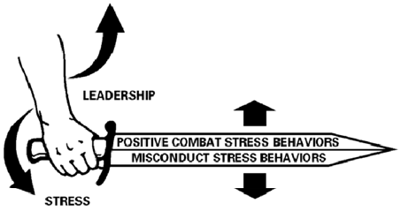

Government Work in the Public Domain.

(U.S. Department of the Army, 1994)

**Figure 2**

These irresistible pressures are positive, on the one hand, in that they motivate heroic action on the battlefield for the sheer purpose of survival. On the other hand, these same powerful forces, unharnessed by good leadership, will increase the incidence of various types of misconduct in the battlefield setting, and even in the period following the warrior’s return from combat.

1. **Traumatic Experiences Related to Military Service**

Contemporary studies of military trauma have dispelled the familiar notion that life-threat scenarios are the only types of traumatic events that cause chronic and disabling mental health conditions. While troops may certainly experience imminent threats to their lives on the battlefield, and these conditions may cause PTSD, troops also face significant risks from morally injurious behavior, in which they feel compelled by military authority to violate deeply-held beliefs (Litz et al., 2009: p. 696). While the concept of “moral injury” is still under careful study in military populations, a general framework for evaluating military trauma now includes at least six components: (1) life threat to self; (2) life threat to others; (3) aftermath of violence; (4) traumatic loss; (5) moral injury by self; and (6) moral injury by others (Stein et al., 2012: p. 802 app.). Stein and his colleagues have identified specific types of maladaptive behaviors linked to these different types of trauma. For example, they have noted “Moral Injury by Self was the best predictor of re-experiencing symptoms (pp. 799-800). This new framework also identifies specific sources of military trauma that result in criminal behavior, such “Moral Injury by Others,” which was most associated with anger and threat of violence to others (p. 800).

The 2010 Navy and Marine Corps’ *Combat and Operational Stress Control* guide marked a significant departure from prior doctrinal publications by incorporating a multi-cause approach to the evaluation of stress injuries related to military trauma. Recognizing that not all service members and combat veterans experience trauma the same way, the *Guide* implemented various zones of stress injuries, each with the potential to result in maladaptive, and often criminal, behavior. Under the general concept of Operational Stress Injuries (OSIs), the guide uses different color bands to signify the service-related behavior that characteristically results in “losses of control,” including “violent images or thoughts that keep popping into awareness and can’t easily be pushed aside,” “intense and uncharacteristic anger,” and “sudden outbursts of rage” (U.S. Department of Navy & U.S. Marine Corps, 2010: p. 4-18).

This new framework, which largely arose from the research and advocacy of Navy Psychiatrist Captain (Ret.) William Nash, represents a paradigm shift in the evaluation of service-related trauma by accepting more subjective evaluative criteria below a standard of diagnostic precision. Under this model, even where behaviors represent mere symptoms of diagnosable disorders, they are still serious enough to merit intervention and careful monitoring by military authorities. Such concern is merited by studies indicating that persons who fall short of a full-blown PTSD diagnosis may still experience certain symptoms of the disorder with more intensity than one who has the diagnosis (Grieger, Benedek & Ursano, 2011: p. 212). Thus, the recognition of a multi-causal model for common undesirable symptoms from combat operations represents a major shift for the military by accounting for a greater number of service members who are at risk of maladaptive behaviors, including acts of misconduct.

Although the three most common “signature injuries” of Operations Iraqi and Enduring Freedom (OIF/OEF) are PTSD, Traumatic Brain Injury (TBI), and Major Depression (Schell & Marshall, 2008), the spectrum of Misconduct Operational Stress Injuries (MOSIs) extends far beyond these diagnoses. The prominent pathways to criminal offending both in the military and the civilian society include variations ranging from “action-junkie” or “thrill-seeking” syndrome, in which risky criminal behavior substitutes for the exhilaration of combat to “depression-suicide syndrome,” in which the veteran commits an offense for the purpose of prompting police to shoot him or her (Wilson & Zigelbaum, 1983). Many MOSIs are indirectly responsible for criminal misconduct, such as the service member who suffers an adverse reaction from medication intended to manage PSTD symptoms or the all-too-common scenario in which the service member binge drinks (and drives) or uses a controlled substance as a form of self-medication (Brooker, Seamone & Rogall, 2012 app.). These diverse contributors to criminal behavior have led the criminal justice system to reassess the eligibility criteria for offenders with prior military service. For example, in the nation’s largest prison-based Vietnam Veteran PTSD treatment program, the Pennsylvania Department of Corrections provided specialized services to veteran inmates who displayed *any* PTSD symptoms (Flournoy, 1987 (Day Three): p. 396). Beyond this, given the inherently subjective nature of the PTSD diagnosis, in recognition that programs cared too much for PTSD to the exclusion of other more common sub-threshold conditions, many VTCs accept participants based on the presumption that they need some form of trauma-informed treatment, similar to Pennsylvania’s program.

While military members with PTSD from intense and prolonged combat operations are at greater risk of violent and criminal symptoms, many more veterans without the diagnosis have similar needs for treatment and consideration. Regardless of the specific MOSI that contributed to a violation of the law, Admiral (Ret.) Bill Mullen’s thesis in a 2011 letter to the former Secretary of the Department of Veterans’ Affairs underscores the major point: “Many of our returning veterans and Service members experience life-changing events, some of which may cause them to react in adverse ways and get in trouble with the law” (p. 1). The sentiment is echoed by a number of official studies and authoritative sources, including the following comments of physicians in the Army Surgeon General’s Office: “*Maladaptive stress reactions*, which may be transient or persistent, include misconduct or behavioral disorders (e.g., depression or anxiety) that develop or are exacerbated as the result of deployment or combat stress. Stress-related misconduct is usually characterized by rule breaking or criminal behavior . . .” (Ritchie, Schneider, Bradley & Forsten, 2008: p. 30). On this point, evident in the Figure, below, the 2006 Army Field Manual 4-02.51 (FM 8-51), *Combat and Operational Stress Control* manual, expounds upon the variations of misconduct related to “combat and other [military] operations”:

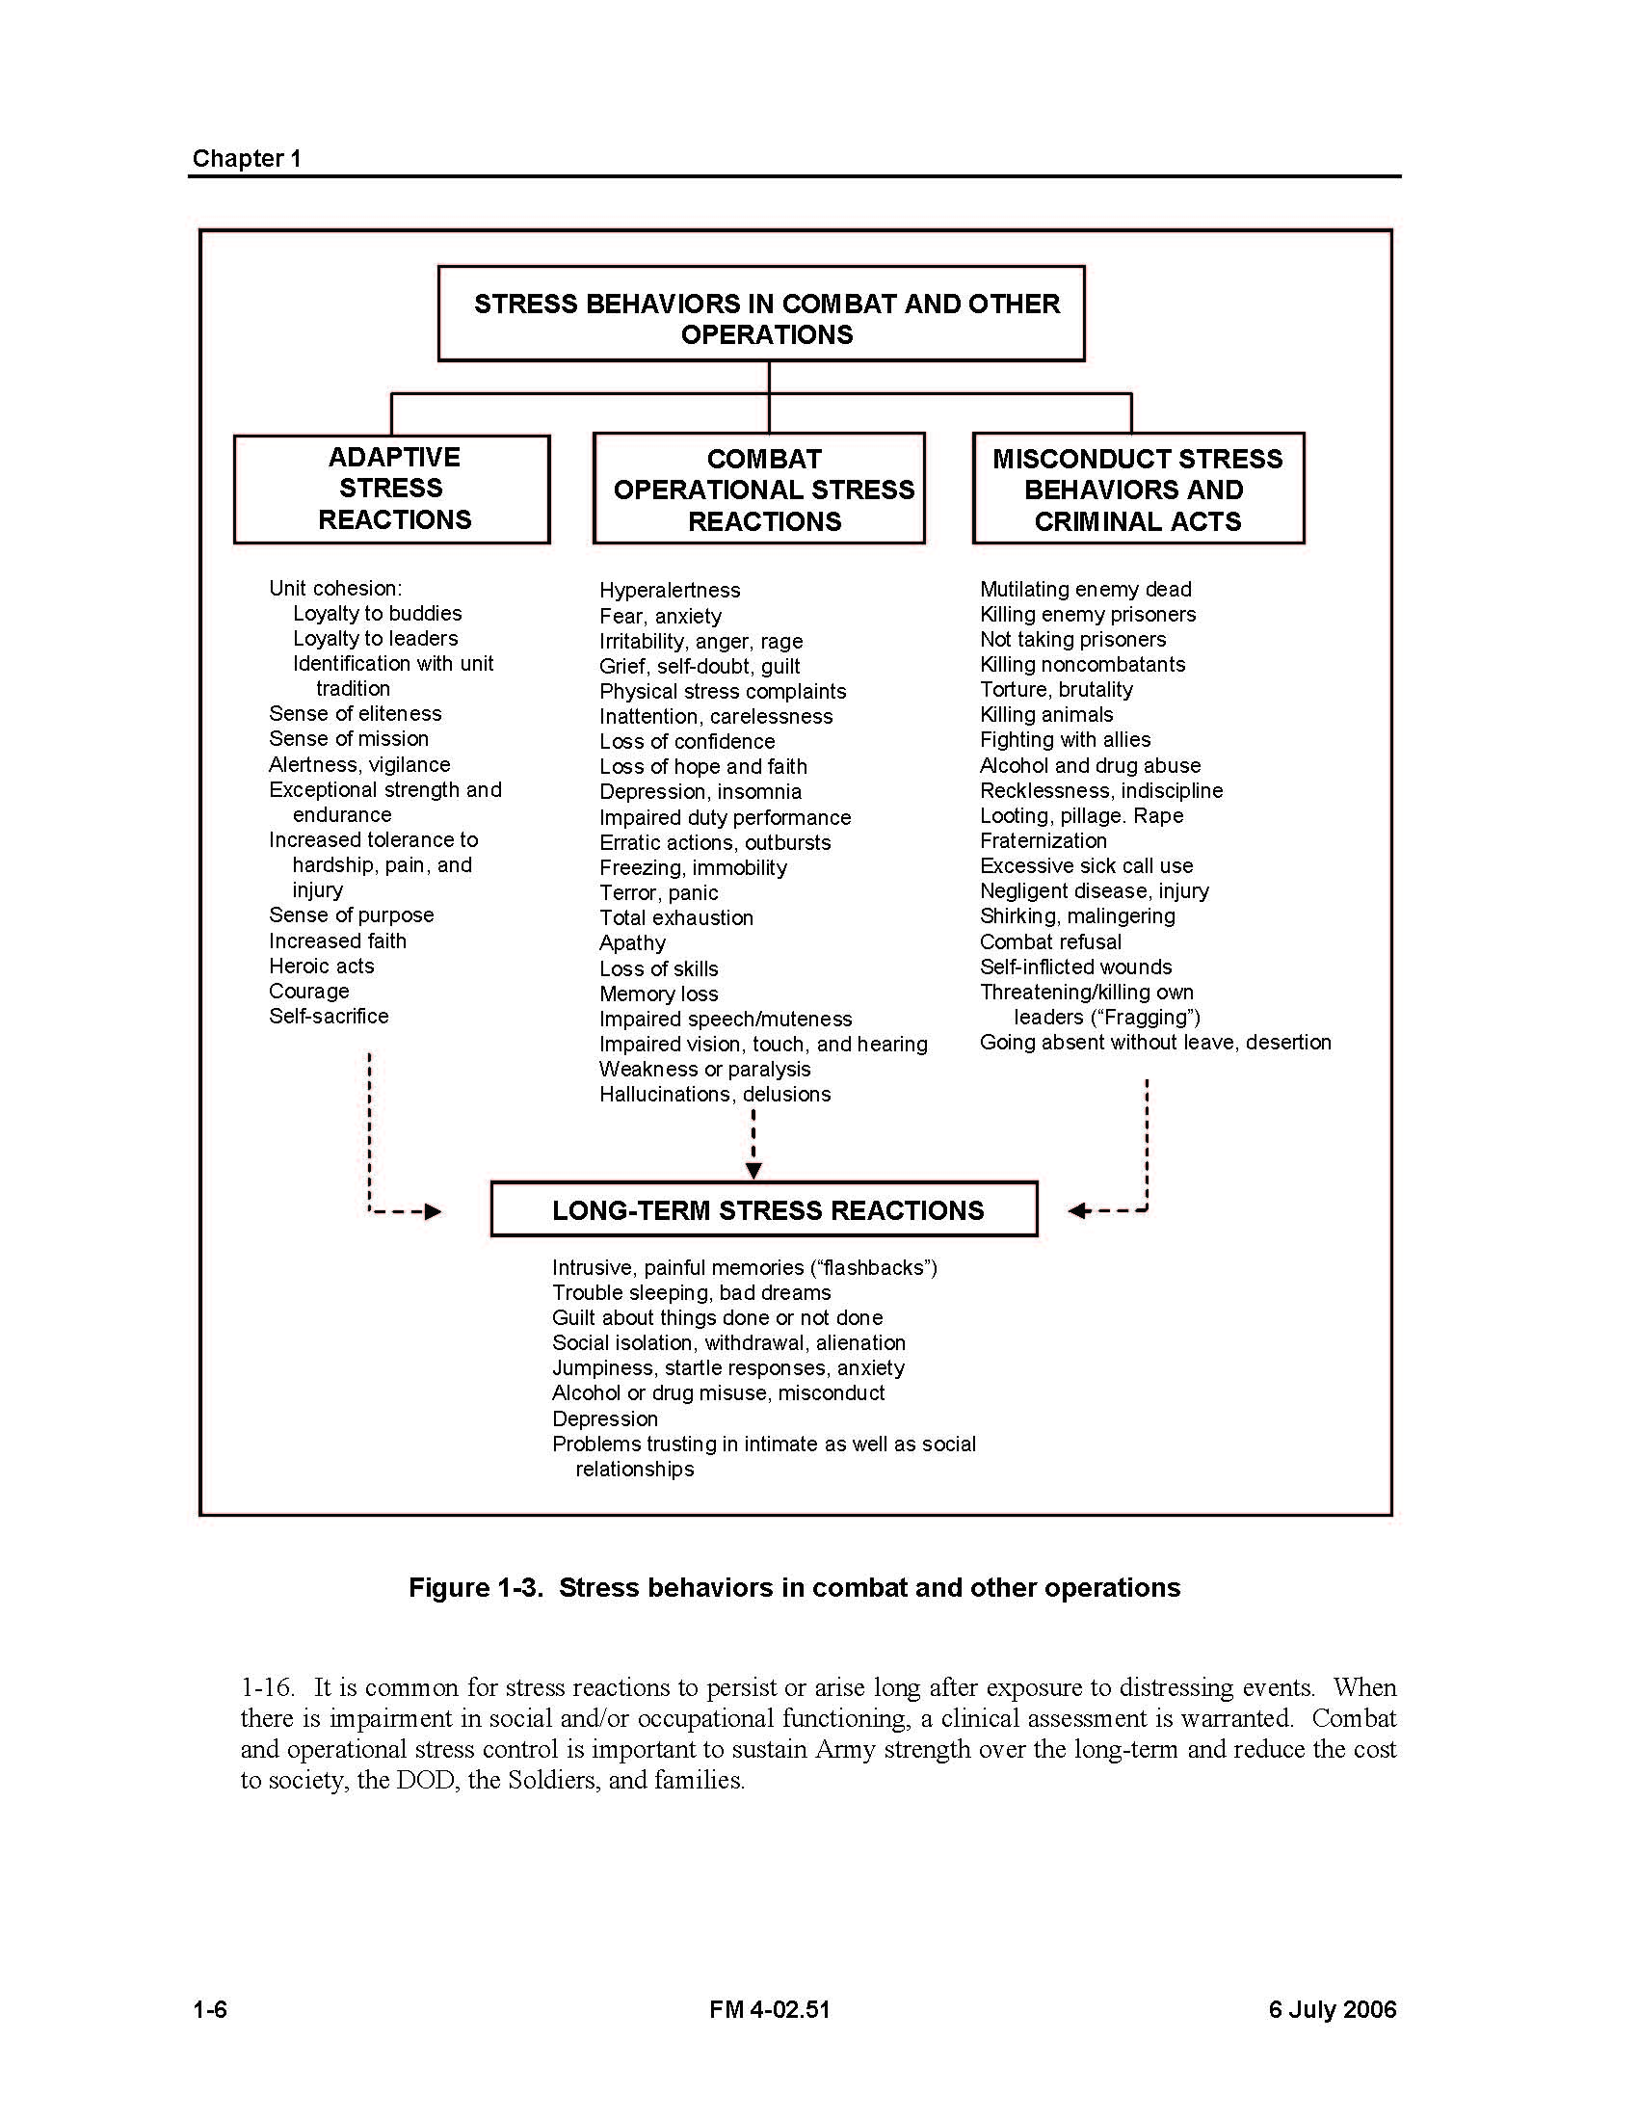

(Government Work in the Public Domain)

(U.S. Department of the Army, 2006: p. 1-6 fig. 1-3)

**Figure 3**

The manual further emphasizes that “Soldiers, however good and heroic, under extreme combat stress may also engage in misconduct” (p. 1-5). Consequently, the next Part describes the types of interventions that exist to provide effective and differentiated treatment to military and veteran offenders, regardless of MOSI type.

1. **Efforts to “*De*carcerate” Military and Veteran Offenders: Common Interventions Along the Continuum of Intercepts**

The VA uses the phrase “justice-involved veterans” to describe individuals with prior military service who are enmeshed in the criminal justice system from the time they are suspects to the time they are released from confinement (Blue-Howells et al., 2013). Since the aftermath of the First World War, the VA (then the Veterans Bureau) has instituted outreach efforts to identify veterans in confinement and obtain treatment instead of jail whenever possible (Seamone, 2013b). The most robust and comprehensive efforts came at the urging of General (Ret.) Eric Shinseki, who explicitly included justice-involved veterans as a necessary component of his then-five-year plan to end veteran homelessness in America. Through its Veterans Justice Outreach Program and Health Care for Re-Entry Veteransprograms, the VA structured its outreach services using Muntetz and Griffin’s Sequential Intercept Model (Blue-Howells et al., 2013), as evident in the Figure, below.

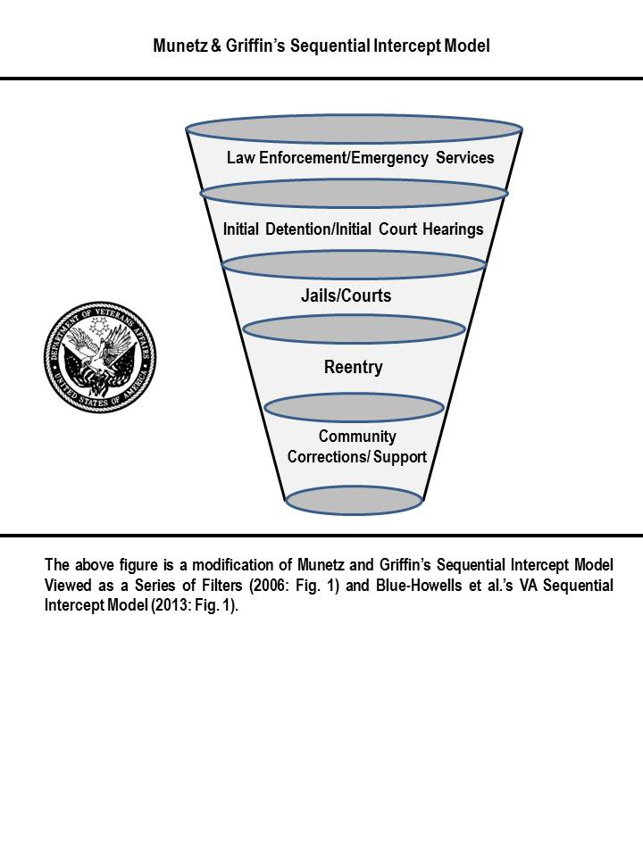

**Figure 4**

The purpose of the VA’s model, and the Sequential Intercept Model in general, is to divert veterans with mental illness from incarceration by providing treatment-based alternatives or by assisting veterans after their release to prevent recidivist criminal activity.

The VA is not alone in grafting its services onto the Sequential Intercept Model. As explored in the subsections below, common intercepts that fall along the spectrum of criminal justice system interventions include: (1) methods to quickly identify veterans to law enforcement; (2) Crisis Intervention Training (CIT) for law enforcement and correctional officers; (3) peer-based counseling at the crime scene; (4) VTCs; (5) sponsored Veterans Groups at prisons and jails; (6) specialized housing units in jails and prisons; and (7) pre-release reentry training and claims-development. Regardless of type and resource allocation, each of these seven interventions which represent a significant transformation of the criminal justice system, requires a method for identifying persons with former military service, and, in some cases, the source of their service-related trauma, the nature of their symptoms, and their eligibility for VA benefits. Importantly, veteran-specific interventions within the civilian criminal justice system, even at the local and municipal level, often require a significant degree of cooperation and partnership between federal and local government agencies.

1. **Methods to Quickly Identify Veterans to Law Enforcement**

Law enforcement officers have come to recognize that veterans and military members are different from other offenders because many of them have specialized training to be lethal (Etter, McCarthy & Asken: 2011), thus posing a “unique threat” (Lavely, Neil & Miller, 2009: p. 3). In fact, patrol officers share the experience of being sized-up by a veteran as they approach in the same manner the officers have been trained to evaluate potential threats (Murphy, 2013: Personal Communication). Crisis de-escalation is therefore a necessity for officers responding to calls involving veterans and military members. Of course, officers do not always have the luxury of being able to determine a suspect’s current or prior military status. In recognition of the need for a modified approach to interactions between law enforcement and former or current military members, a number of states have implemented legislation permitting veterans to indicate their status on license plates and drivers’ licenses. Beyond this, Georgia permitted veterans to indicate PTSD diagnoses on their drivers’ licenses specifically to avoid confrontations with law enforcement (Seamone, 2011). Although these efforts are not as robust as hands-on interventions in that they only provide a means to identify individuals, these efforts still represent a sequential intercept in their aims to prevent clashes that would otherwise contribute to arrest or incarceration.

1. **Crisis Intervention Training**

Today, almost all law enforcement organizations conduct training in crisis de-escalation for persons with mental illness. The contemporary model grew out of an incident in Tennessee in which police shot a symptomatic man during an encounter leading to demands that officers to receive better training in nonlethal communication skills (Morabito, Watson & Draine, 2013; (Compton et al., 2011). From the time of the first comprehensive CIT training in the late ‘80s through the present, programs have incorporated a veteran component, largely informed by the criminal justice system’s experience with Vietnam Veterans. In many instances, officer trainees visit VA hospitals to meet with veterans and learn of their personal experiences with severe OSI symptoms. In 2006, in the advent of a two-front war in Iraq and Afghanistan, the Chicago Police Department developed a 40-hour CIT program tailored specifically to the challenges presented by suspects with military experience. Notably, many graduates of the program, who were themselves veterans, recognized their own need for care from the VA when they realized that they had been suffering from many of the same OSI symptoms (Murphy, 2013: Personal Communication). Through these programs, and the work of hostage negotiation specialists who have seen significant numbers of veterans involved in hostage-barricade incidents (Etter, McCarthy & Asken, 2011), law enforcement agencies have developed protocols for communicating with veterans and military members in distress. In many instances, trained first-line responders are able to de-escalate volatile situations simply by announcing their movements, thanking veterans for their service, and drawing on similarities between their law enforcement duties and the duties performed by the veteran during military service (Weaver et al., 2013; (Lighthall, 2013).

1. **Peer-Based Counseling at Crime Scenes**

In large cities like Los Angeles, trained veteran counselors sometimes accompany officers on patrol because veterans and military members normally relate better to people with prior military service in times of crisis (Seamone, 2011). Largely as an effort to eliminate the distance that emerges with comments, such as, “You don’t know what is was like for me,” peer-based interventions have enjoyed significant success. At both prisons and jails, in fact, the most successful specialized programs for veteran detainees and inmates incorporate correctional officers and sheriff’s deputies with prior military service. Many CIT trainers would prefer that designated first-responders in police departments have prior military service for this same reason (Murphy, Personal Communication: 2013). Recognizing that military members are a distinct cultural group with their own language, shared values, and ideals (e.g., Strom et al., 2012), veteran interventions with peer components likely represent a more culturally competent practice.

1. **Veterans Treatment Courts**

As of June 30, 2014, at least 220 VTCs operated in at least 32 states across the country with many more in the planning stages (National Drug Court Resource Center, 2014; Wolfe, 2013; Baldwin, 2013). They represent specialized problem-solving treatment programs designed to target specific addictions and behavioral issues in recognition that punishment without the opportunity to treat underlying conditions only touches upon criminal *symptoms* rather than criminal *causes* (Seamone, 2011). The specialized court movement grew from the innovation of judges in Miami- Dade County Florida who faced repeat drug offenders. Some of these habitual minor offenders were essentially serving life sentences “thirty days at a time” (Berman & Feinblatt, 2005: p. 15) (citing Judge Alex Calabrese). In 1989, the first drug treatment court emerged with a docket devoted solely to drug offenders, a treatment court judge who would regularly monitor the participant’s progress through regular status conferences in court, and an interdisciplinary treatment team to provide rewards and sanctions based on the participant’s drug abatement and efforts at rehabilitation. That initial effort eventually led to the development of at least 2,459 Drug Treatment Courts by 2009 (Huddleston & Marlowe, 2011). Soon after the Drug Treatment Courts flourished, specialized Mental Health Treatment Courts emerged adhering to common core principles. Today, VTCs represent the 14th variation of specialized treatment court in the nation (Seamone, 2011). While the section below explores some unique attributes of VTCs, they are different from other programs in a singular important way; their growth rate since the inception of the flagship Buffalo Veterans Treatment Court in 2008 is more explosive than any other specialized court program in history, to include Drug Treatment Courts (Justice for Vets, 2010).

Contrary to a prevailing view of VTCs as entirely separate court systems, at most, all of these programs involve special court sessions of existing criminal courts with dockets limited to former or current military members. For example, while arraignments for general offenders might take place on a Wednesday morning, the veterans’ docket would meet on a Thursday afternoon. Presiding VTC judges are normally experienced judges who have other duties, such as presiding over non-veteran dockets and other specialized treatment court dockets. Like all problem-solving court dockets, the program depends upon the involvement of a team of professionals, including a prosecutor, a defense attorney, and mental health professionals. Similarly, in all problem-solving programs, offenders participate in order to avoid consequences which might include conviction or a jail sentence depending upon the structure of the program and the nature of the offense (Baldwin, 2013). If the participants demonstrate responsible and desired behavior for a specific period of time, they “graduate” from the program with a new opportunity for societal redemption. While national problem-solving court programs vary in many ways, they generally adhere to treatment court principles and their success largely depends upon the individual personalities of the judges and the synergy between the treatment team members (Seamone, 2011).

Like other problem-solving court programs, no two VTCs operate in exactly the same manner—even within the same state (Seamone, 2011). They do, however, have two unique attributes that other problem-solving treatment courts lack. First, unique to VTCs, the treatment team necessarily includes an employee of the federal VA to schedule appointments in the VA healthcare system, enroll veterans in residential treatment programs, and confirm VA benefit eligibility in individual cases. This unprecedented partnership began by chance with Buffalo Veterans Treatment Court Judge Robert Russell, Jr., developed a program and informally invited associates from the VA to participate. Since that time, the VA’s Veterans Justice Outreach noted the tremendous benefits of a presence within local criminal courts and established regional positions devoted to court outreach, especially within existing VTC programs (Rosenthal & McGuire, 2013).

In 2008, Judge Russell’s experiment with a specialized docket for veterans also signified the other unique attribute of VTC programs. The genesis of the Buffalo Veterans Treatment Court was a particular incident that occurred with a veteran offender during Judge Russell’s Drug Treatment Court docket (Russell, 2008; Salem, 2011). Judge Russell faced tremendous difficulty in communicating with a veteran during arraignment. After several attempts, he asked a court administrator with prior military service to speak with the veteran and try to get through to him. Out in the hall, the administrator, Mr. Jack O’Connor, recruited another veteran to convey the importance of pride in veteran status. They encouraged the man to stand tall as he did during his military service. By the time the veteran returned after this pep talk, he stood at the position of parade-rest, responded directly, and professed a commitment to fully participate in the program. This event formed the genesis of all VTCs requirement for veteran peer mentorship as the second major component of VTCs. When Admiral Mullen (2011) spoke of the special value of VTCs, he also recognized the value of this peer component in transforming the lives of veteran offenders.

Inevitably, VTCs differ with many disallowing participation for violent and felony offenses. Some programs leave participation decisions to the treatment team’s discretion, while others admit participants based on strict statutory requirements with little room for judicial or treatment team discretion. Other VTC programs refuse to admit former military members with less-than-honorable discharges normally because the VA bars treatment for many recipients of stigmatizing discharges. Judge Russell has adopted a relatively liberal participation threshold, not only enrolling felons and violent offenders, but family members of veterans and even federal veteran offenders when permitted to enroll by the United States Attorney’s Office in the Western District of New York (Seamone, 2011). Despite the several variations, VTCs collectively represent a monumental shift in criminal justice practice. The new paradigm (since 2008) represents widespread acceptance of a nexus between prior military service, particularly traumatic military experiences, and later involvement in the civilian criminal justice system as a result of those experiences. It further represents a recognition that the military is not able to identify or resolve all cases of service-related mental health disorders that contribute to military offending. Most importantly, the development of these programs represents formal recognition of the civilian criminal justice system’s role in linking veterans with their benefits and obtaining treatment for them when the military is unable to do so.

1. **Sponsored Veterans Groups at Prisons and Jails**

Veterans represent a significant portion of the nation’s prison and jail population and have for some time (Noonan & Mumola, 2007; Mumola, 2000; Casey, 1923). Accurate statistics have been hard to come by because veterans have not normally been asked to identify themselves and because, even when asked, many are ashamed of identifying themselves as criminals (MacPherson, 1993). The existing underrepresented, albeit unrepresentative, figures suggest that less than 10%, even 5% of the nation’s prison population, has prior military service (Rosenthal & McGuire, 2013). While the number represents far fewer military inmates and detainees than civilians without military service, this figure represents *the* largest number of offenders with a single occupation in confined settings. Notably, one of Secretary Shinseki’s last major initiatives before his resignation was the development of the Veterans Research Search Service (VRSS), which enabled verification of an inmate’s military service record and eligibility status through a computer match of Social Security Number. The VRSS program was piloted in a number of institutions before its unveiling in 2013. Tests with inmate populations in California revealed that correctional administrators vastly undercounted their veteran population, uncloaking the identity of more than twice the number of estimated veteran inmates (McGuire, 2013: Personal Communication) (revealing initial estimates of 2.7% and confirmation of 7.9% of inmates with prior military service).

Because confined veterans have been identified as a “special needs” prison and jail population (Gideon, 2013), this status underscores the need for programming, especially when they have pressing mental health needs and problems adjusting to confined environments. The 1970s was a watershed moment for confined veterans in America. At that point, traditional veterans’ service organizations largely avoided incarcerated veterans in efforts to preserve their good reputations as the “greatest generation” from WWII (MacPherson, 1993). Without outreach and institutional support, Vietnam Veterans created their own membership organizations behind bars, such as Vietnam Veterans of America prison chapters (May, 1979). The prison groups helped train their own members to file VA claims for benefits such as the Montgomery G.I. Bill, with some inmates becoming so proficient that corrections officers would file their own VA claims with the inmates’ assistance (May, 1979). Informally, these membership organizations also served as a support network for veteran inmates, often coordinating visits from Vet Center counselors and engaging in peer counseling for common symptoms experienced in confined settings. As of 2010, approximately 227 veterans’ groups operated in the nation’s prisons (Rosenthal & McGuire, 2013).

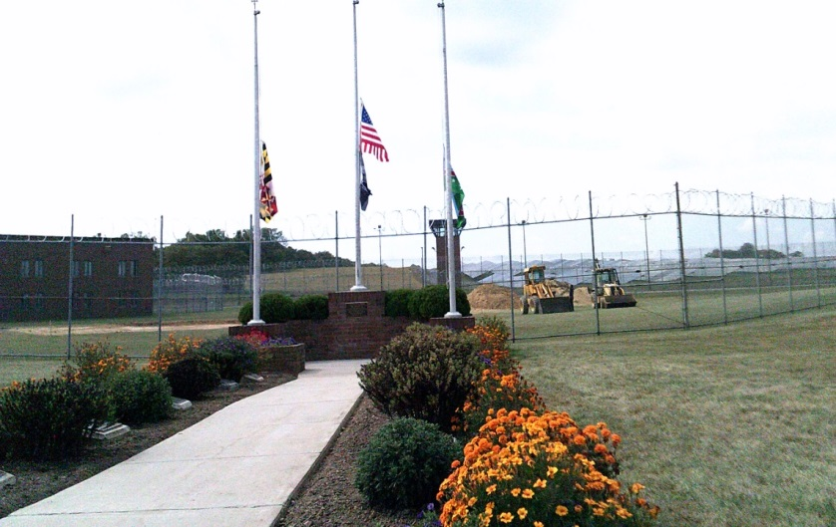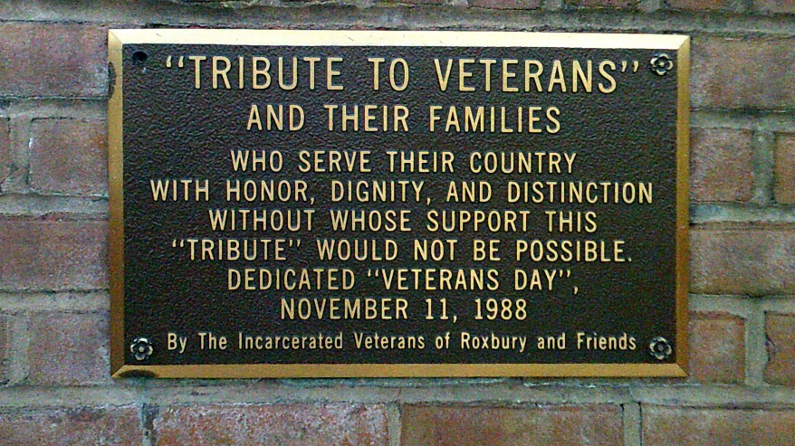 A noteworthy example is the Incarcerated Veterans of Roxbury (I.V.O.R.) program that has operated at Roxbury Correctional Institution in Hagerstown, Maryland, for decades. That program has achieved widespread notoriety in Maryland and beyond based on the inmates’ creation of one of the few veteran monuments on prison grounds built by inmates.



**Figure 5** © 2013 Evan R. Seamone

During a visit by the author, the Warden shared his belief that the members of the I.V.O.R. were model inmates who lead by example. The members participate in various community service activities both in the prison walls and beyond, and are permitted to wear individualized polo shirts for family visitation and other special events which depict their branch and years of service, their names, and special illustrated badges for achievements while in the program.

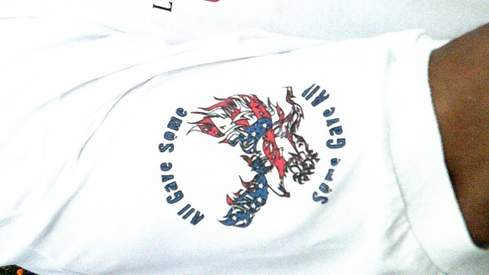

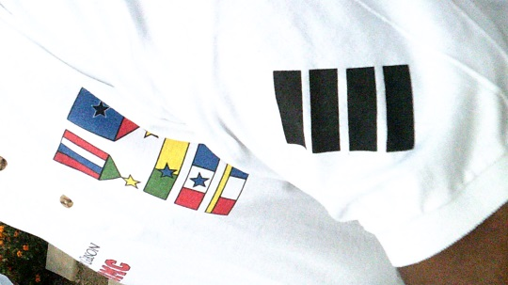

Depicted above are the left and right sleeves of the I.V.O.R. polo shirt worn by

members of the organization. While the right sleeve is generic, the left sleeve uses

black bars to signify the number of years the veteran served in the U.S. military.

© 2013 Evan R. Seamone.

**Figure 6**

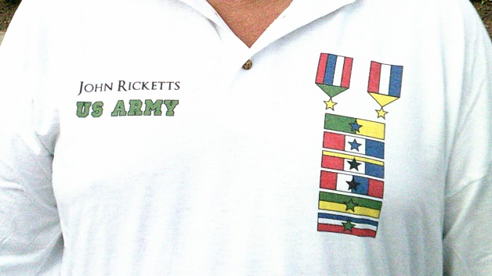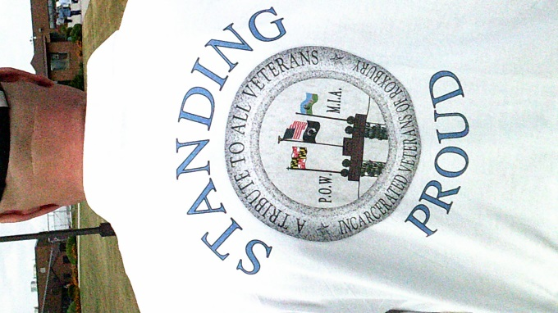

Depicted above is the back of the I.V.O.R. polo shirt for all members

of the organization (l) and the front of a polo shirt of a more decorated veteran officer

within the organization, who had prior service in the United States Army (r).

© 2013 Evan R. Seamone

**Figure 7**

Not unlike Hagerstown, the veterans group in Texas’s Mark W. Stiles Unit has color guard members who are permitted to wear special ceremonial regalia for official events, as depicted in the Figure, below.

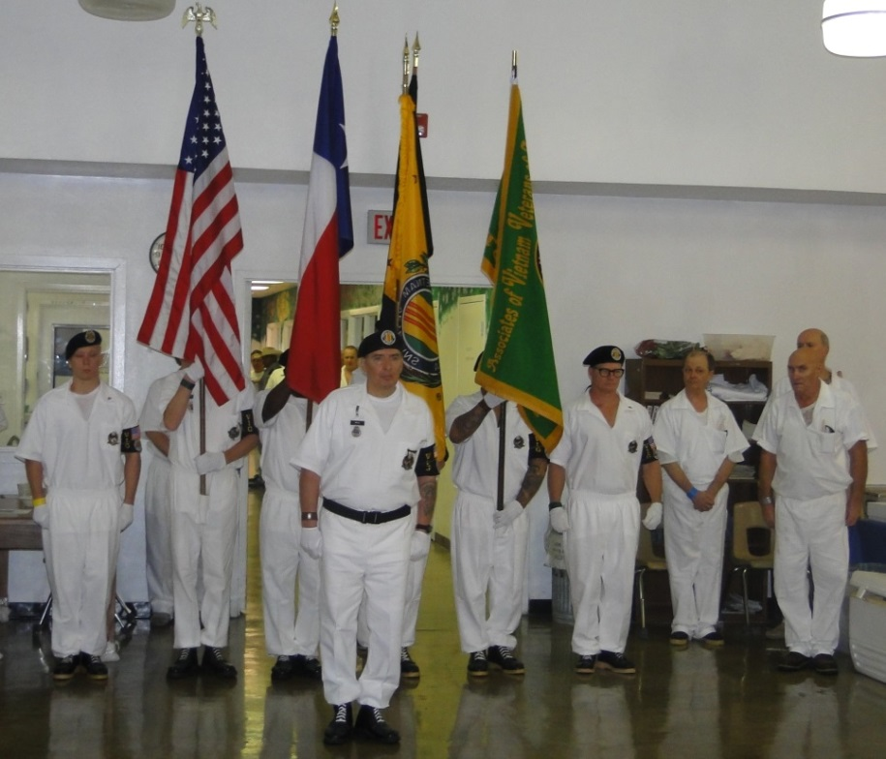

Depicted Above, Inmate Members of the VVA Participate in an Elaborate Color Guard

Ceremony for Fallen Veterans from the Community While Simultaneously Celebrating the

Organization’s14th Anniversary at the Texas Mark W. Stiles Unit

© 2013 Sandra Womack Reprinted with Permission

**Figure 8**

Although these programs exist in the shadows of prison walls and barbed wire fences, the numerous veterans groups in confined settings speak to the value of harnessing the common pride and experience of serving the nation during otherwise abysmal times. In this regard, the Vietnam Veterans of America uses the phrase “Veterans Incarcerated” to signify that, before they were inmates, these offenders were—and will always be—veterans first (Rideau, 1976).

1. **Specialized Housing Units for Veterans in Prisons and Jails**

In 1994, based on his experiences treating Vietnam Veterans in Arizona’s Federal Correctional Institute at Phoenix, Psychologist Chester Sigafoos coined the phrase “second tour” to describe incarcerated veterans’ experiences in confinement. On this view, the hallmarks of imprisonment, such as authority figures giving orders and not knowing where the next attack might originate, invoked the same survival mindset as combat tours in Vietnam. Sigafoos encouraged incarcerated veterans to be aware of these similarities in order to avoid instinctual reactions that would create further problems for them while incarcerated. This survival mentality is even more prominent today since most OIF/OEF veterans have served numerous combat tours, in comparison to Vietnam veterans. Currently, some prison systems and jails have taken more direct action to avoid the “second tour” and capitalize on the positive aspects of veterans’ military experiences. As the Director of the Federal Bureau of Prisons observed in the 1950s, veterans share cultural attributes that incline them to be model prisoners: “All of the 29 federal prison wardens and camp superintendents agreed that by and large the ex-GI made a better adjustment, profited more by the rehabilitation program, and generally found it easier to adjust than the man who had no military experience” (Bennett, 1954: p. 42). These inmates largely understand the importance of obedience to authority and know how to work in teams, as opposed to career criminals and civilian offenders. Further, by harnessing these positive attributes, jails and prisons can decrease the potential for harm to their staff from the undesirable characteristic of lethal training in hand-to-hand combat and improvised weapons.

Although the New York Department of Correctional Services has operated the longest running residential program, the Veterans Residential Treatment Program (Marks, 2001), since 2005, city jails like Los Angeles toyed with different versions of a veterans dormitory in its Men’s Central Jail (Leondard, 2005), with the great majority of programs emerging in correctional systems across the nation in the five years between 2010 and 2015. Today, a total of 17 programs operate in 14 states, as depicted in the chart below, based upon the author’s research:

**List of States With Specialized Veterans Housing Units as of September 2015\***

**Prison Jail**

**AZ X**

**VA X**

**NY X X**

**ME X**

**PA X**

**GA X**

**IN X**

**FL X**

**CA X (3)**

**IL X**

**MO X**

**TX X**

**OH X**

**CO X**

* AZ: Maricopa County Sheriff’s Department; VA: Virginia Department of Corrections; NY: Errie County Sheriff’s Department and New York Department of Correctional Services; ME: Kennebec County Sheriff’s Department; PA: Pennsylvania Department of Corrections; GA: Muscogee County Sheriff’s Department; IN: Indiana Department of Corrections; FL: Florida Department of Corrections; CA: San Francisco Sheriff’s Department, San Diego Sheriff’s Department; Los Angeles Sheriff’s Department; IL: Cook County Sheriff’s Department; MO: Jefferson County Sheriff’s Department; TX: Austin Sheriff’s Department; OH: Ohio Department of Rehabilitation and Corrections; CO: El Paso County Sheriff’s Department.

(Seamone & Albright, 2016)

**Figure 9**

The programs have different aims and structures, with some like the Florida and Virginia Department of Corrections’ Veterans Dorms operating similar to boot camps with specific military-themed duties, uniforms, and parade formations (Breen, 2011; Vergakis, 2012), and others, such as San Francisco, California’s Community of Veterans Engaged in Restoration and Kennbec County, Maine’s Veterans Dorms designed more with an eye toward the creation of a therapeutic environment in which detainees can begin to recognize how their maladaptive symptoms from military service manifest (Schwartz & Levitas, 2011; Schroeder, 2013). Despite some variance in residential programs, these segregated housing units all represent a cost-effective method to deliver veteran-specific services to inmates and detainees while each also increases officer safety and minimizing the chance for misconduct in the general population.

1. **Pre-Release Reentry and Claims Development Interventions**

The VA, in contrast, is challenged by administrative regulations that bar any sort of direct medical care or treatment for incarcerated veterans. For decades, Section 17.38(c)(5) of Title 38 of the Code of Federal Regulations has prohibited these services on the basis that the jail or prison has primary responsibility for providing care to its detainees and inmates (Hager, 2009). For veterans with mental health conditions and other severe health problems, this theory of “duplicated” healthcare services ignores the fact that the VA has specialized services and protocols for combat-related conditions that no prison or jail would be able to offer amidst a crisis in healthcare for all inmates. During a period of incarceration, VA employees are thus limited to providing information regarding benefit eligibility and the filing of claims (Rosenthal & McGuire, 2013). Under these significant constraints, the outreach specialists help develop post-release and reentry plans in an effort to link the veteran with needed benefits *upon release*. Because the most volatile period for a former inmate is shortly after release, these efforts have proven extremely helpful in preventing suicide and veteran homelessness, representing a vital intercept at the farthest end of the spectrum of interventions.

1. **Pre-Discharge Military Service as the Ultimate Intercept for Veterans: Combatting the Over-criminalization of Mental Illness in the Armed Forces**

In more recent years, the military has commenced a substantial drawdown in forces to meet fiscal objectives. These efforts are purging the ranks of many formerly deployed troops in different stages of post-combat readjustment and reintegration. Civilian agencies are increasingly concerned with the influx of veterans who have serious problems including health challenges, family conflict, interpersonal violence, joblessness, suicide, and criminal involvement. Recognizing the need for specialized services and scarce civilian expertise in treating mental health conditions related to combat trauma, these civilian entities naturally turn to the VA for the most effective programs. Despite concerns about waiting times to obtain healthcare and stories of egregious behavior at VA medical centers, the VA still offers unparalleled services, including poly-trauma treatment centers, specialized clinics for women veterans, and voucher programs to obtain short- and long-term housing for veterans at risk of homelessness (Seamone, 2011; Seamone, 2014). Too many civilian healthcare and social services providers, however, are learning that discharge characterization is often a bar to the receipt of these meaningful services from the VA.

Research within the VA estimates that 20% of justice-involved veterans are not eligible for healthcare or other VA benefits based upon their receipt of an other-than-honorable discharge characterization (Rosenthal & McGuire, 2013). All of these stigmatizing discharges are solely attributable to misconduct during military service under the operation of military laws and regulatory provisions that have no analogue in the civilian justice system. Many of these discharge recipients were ejected after spending a relatively short period of time in the service when they were relatively young and entirely dependent on the military for housing, food, living expenses, etc. The result of involuntary administrative or punitive separation with a stigmatizing discharge is a person with few opportunities for social advancement and healthcare (Slavin, 1975; Waters & Shay, 1994). The scarlet letters UD (undesirable), OTH (other-than-honorable), BCD (bad-conduct discharge), DD (dishonorable discharge), and DIS (dismissal) haunt most recipients for the rest of their lives beginning shortly after their ejection. With the help of the Veterans Service Organization Swords to Plowshares, a “bad paper” campaign has increased public awareness of former service members with acute mental health needs turned away from the VA and living in the streets as a result of their discharge characterizations for relatively minor offenses against good order and discipline in the military (Swords to Plowshares, 2015).

1. **The Mantra of “Good Order and Discipline”**

Military discipline exists to be harsh and swift for good reason: young troops are

extremely impressionable and can only function optimally in an operational environment that values obedience to authority. This basic premise, which has existed since the inception of the world’s first armies and navies, places disciplinary authority in the hands of the military commander and has traditionally provided that individual with wide discretion to tailor a fitting punishment based on the circumstances of the offensive behavior (Marinello, 2007). Because of these realities of military service, there are stark differences between the military and civilian justice system. First, the military has several crimes that are unique to service in the armed forces. Because disobedience, lateness, and disrespect of superiors can cost lives on the battlefield, federal laws criminalize such behavior and assign maximum punishments in contemplation of the most egregious instances. Alternatively, these laws impose no articulated minimum punishments, permitting commanders to easily dispose of less severe offenses (Seamone, 2013). Far separated from civilian penalties, most military crimes include the consequences of fines, reduction in rank, forfeiture of pay and allowances, imprisonment, the stigma of a federal conviction, and a punitive discharge from the Service. The punitive discharge is considered a punishment because of the substantial handicaps it generates in civilian life and it is a label with no civilian counterpart. In many cases, commanders will send charges to a court-martial in the hope that a judge or military jury (panel) will issue a punitive discharge since the discharge would result in prompt ejection from military service. In recognition of this need for speed, the court-martial is designed to be very versatile, and, with no standing judges, may be convened anywhere in the world on a temporary basis for as long as it takes to render a verdict and a sentence.

The trouble with courts-martial is the time it takes to reach the trial stage. In order to meet procedural due process requirements, and with inherent delays and mental health evaluations, it can take nearly a year or more to bring a case to court, leaving military units with a heavy burden of supervising the offender through the duration of time. Unlike civilian courts, commanders and unit leaders are responsible for the offender’s health and well-being unless he or she is placed in pretrial confinement after a military magistrate’s review. During Vietnam, the military offered commanders additional administrative separation proceedings as tools to promptly separate a service member for acts of misconduct. Administrative discharges provided fewer procedural protections, no rules of evidence, and a lower burden to meet the criteria for involuntary separation (preponderance of the evidence rather than proof beyond a reasonable doubt). Moreover, although not intended to be punitive like a BCD, DD, or DIS, the unit could seek a negative discharge characterization that was first called an Undesirable and later changed to the Other-Than-Honorable Conditions (OTH) discharge. For all practical purposes, the OTH led to comparable consequences as the BCD with regard to ineligibility for VA benefits (Brooker, Seamone & Rogall, 2012).

Thus, in modern times, commanders use both the administrative OTH discharge and the punitive discharge from a court-martial to mete out discipline in their units, with no definitive guidelines for the method of exercising their disciplinary discretion. If anything, the recent focus on shedding personnel has increased pressures on commanders to eliminate poor performers with fewer opportunities for rehabilitation. While some military publications suggest that commanders are getting soft on crime, evident in fewer instances of nonjudicial punishment, other data reveal proportionately greater instances of BCDs and DDs during the Global War on Terror as compared with Vietnam (Seamone et al., 2014). Moreover, in the years between 2001 and 2013, approximately 122,000 military members were separated on these grounds of misconduct with the VA refusing to recognize 117,000 of them simply as a result of their discharge characterization (Adams & Millard, 2015). Recalling the earlier discussion of MOSIs as predictable and inevitable occupational hazards of military service, coupled with additional evidence of prevailing stigmas against help-seeking, many discharge recipients whose misconduct was related to their service-related trauma undoubtedly have ongoing mental health treatment needs.

1. **The “Military Misconduct Catch-22”**

Often, judges, attorneys, police, and employers are default first-responders to the symptoms of OSIs (Seamone, 2009; Seamone 2011; Seamone, 2014). Law enforcement officers can attest that many veterans come to realize the need for diagnosis and treatment only as they are sitting in the back seat of a police car in recognition that they lack the individual coping skills to mitigate the negative effects of their condition (Seamone, 2011). In the same light, the military police car often serves that same function. However, the military lacks the same interest and resources to assist its offenders (Seamone, 2011; Seamone, 2013). In many cases, the military is punishing its soldier-patients with stigmatizing discharges for operational injuries they sustained during faithful service (Seamone, 2011; Seamone, 2013; Seamone et al. 2014). Seasoned attorneys who have attempted to preserve benefits for this group describe a widespread “military misconduct Catch-22,” in which it is simply too late to obtain treatment for military offenders with ongoing mental health needs because military offenders are too far along the pathway to punitive or administrative separation (Seamone, 2013).

In many of these heartbreaking cases, the downward spiral can be traced to a specific deployment or traumatic point in time before which the troop performed admirably with no blemishes on his or her record. Moreover, many of these cases involve “misconduct” that is emblematic of the common symptoms of the three “signature invisible wounds of war” (PTSD, TBI, and Major Depression) as well as a host of other OSIs. In the military context, where deficits in work performance are punishable by years in prison and a punitive discharge, symptomatic but undiagnosed and untreated service members run the risk of a disciplinary response at disproportionately higher rates than those service members without OSIs (Seamone, 2013). The research of Robyn Highfill-McRoy (2011) underscores this point in the revelation that service members with PTSD in a sample of over 70,000 war-deployed Marines were *eleven times more likely to be punitively discharged* from the armed forces than Marines without PTSD.

1. **The Pre-discharge Intercept as the Most Vital Intervention for Military Members**

The consequences of over-criminalization of mental illness in the military and the associated “Military Misconduct Catch-22” are mainly borne out on civilian society with few consequences to the armed forces. The impact of these discharges is not limited to the ex-service member but rather his or her children and family members who are at significant risk of acquiring secondary traumatic stress when symptoms go untreated (Seamone, 2012). In 1994 Congresswoman Maxine Watters and VA Psychiatrist Jonathan Shay traced the impact of these discharges to a host of societal consequences including tolls on emergency medical services, healthcare, and other social services. In concern for commanders’ lack of knowledge of the nexus between military operations and OSI symptoms and the impact of their disciplinary decisions on offenders’ eligibility for mental health treatment from the VA, in the 2015 National Defense Authorization Act, Congress mandated the Comptroller General to identify the nature of this deficit and finally quantify the number of military members with mental health needs who were ejected with stigmatizing discharges and thereby rendered ineligible for benefits.

Because the military justice system is so dependent upon individual commanders’ exercise of discretion to achieve outcomes, the system requires a nudge similar to the one it received in response to the handling of sexual assault cases, the services accorded to victims, and the pursuit of perpetrators of sexual assault. Today, as a result of efforts to expose the military to contemporary solutions like Special Victims Units in district attorneys’ offices and police stations and joint training and support from civilian sexual assault response professionals, the military has its own Special Victims Prosecutors, more highly trained advocates, and a method to stay abreast with developments in that highly specialized field (e.g., Kohn, 2010). In much the same way that the military justice system failed to recognize or incorporate civilian advancements in the handling of sexual assault cases, it now lacks an appreciation for the major developments in the civilian criminal justice system regarding MOSIs and the nexus between military service and behavior that is simultaneously symptomatic of mental health conditions and criminal offending.

In a military system that lacks any system of probation, has no sitting judges, and vests pre-trial supervisory responsibility in the same commanders who are pursuing punishment, the time is long overdue to incorporate lessons learned from the civilian sector in community supervision of offenders, treatment teams, Evidence-Based OSI Treatments, the use of sanctions and rewards, and involvement of peer mentors and the VA in achieving short- and long-term objectives. While some initiatives may need modification to meet the demands of military service, the military justice system has the means for suspending both punitive discharges from courts-martial and administrative discharges from separation proceedings and conditioning the remittance of these discharges on specific events, such as graduation from a treatment program or compliance with a treatment regimen (Seamone, 2011).

At a conceptual level, one need only extend the reach of the Sequential Intercept Model back into the period of pre-discharge active military service. The modified figure below depicts the model with an extension for pre-discharge military service.

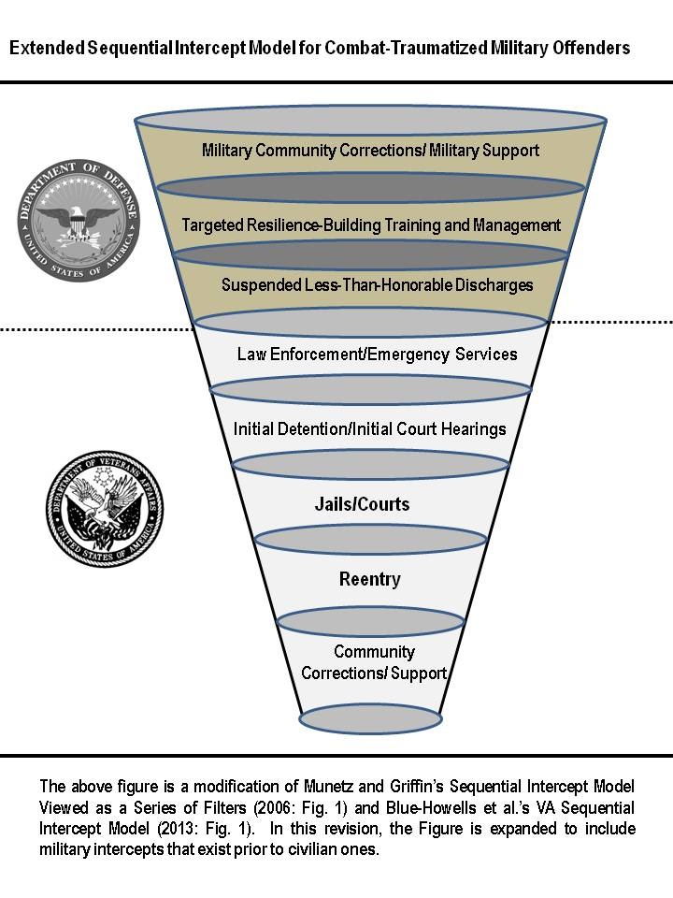

During this ripe period for intervention, rather than *de*carceration, all interventions will ultimately aim toward the goal of a discharge and separation from the service under honorable conditions that would permit receipt of necessary benefits and healthcare for the duration of one’s life as a veteran in the civilian community.

1. **Conclusion**

This paper has shown the significant societal risks that are posed by inflexible and ambivalent application of military discipline on traumatized offenders who require mental health treatment. Despite numerous signals that the military requires a revised approach to discipline of this offender subpopulation, recent trends indicate that there is a tendency to institute minimum punishments and mandatory discharges in the Uniform Code of Military Justice,and the race to separate military members for any derogatory records in their personnel files in the face of massive post-conflict drawdowns, suggest rapid movement toward an even more punitive and less accommodating stance. While new congressional mandates to study commanders’ approaches to traumatized offenders separated with crippling military discharges suggest mounting concern, these efforts lack the momentum and resourcing to effect change in a timely manner. Rather than treating this injustice of military justice as though it were limited only to military circles and the confines of good order and discipline, lawmakers, criminal justice organizations, and public health agencies must address the problem as a growing threat to civilian society.

Public civilian agencies can limit this most severe and acute societal cost of sustained combat operations by recognizing certain military offending as a byproduct of the reintegration process for many service members. From this fundamental premise grows the need to apply the same sorts of intercepts *prior to discharge* as the civilian criminal justice system now extends to veterans who have already been separated from the service. Through partnerships and joint involvement in military policing, supervision of military offenders pending adjudication, civilian housing and job training, and quality mental health treatment, civilian entities can enable the active and reserve components to expand options and develop effective intercepts with the ultimate goal of treating offenders, preserving their post-discharge benefits, and avoiding less-than-honorable discharge characterizations. The costs of avoidance are simply too great.

**Referenced Sources**

ABC News Radio (2013, December 11). Arizona Sheriff Joe Arpaio to House Jailed Vets Together. *WFJA Classic Hits 105.5*. Available at: http://www.classichitsandoldies.com

/v2/2013/12/11/arizona-sheriff-joe-arpaio-to-house-jailed-vets-together/

*A Matter of Duty: The Continuing War Against PTSD* (2013, Nov. 10). Bangor, ME: Maine Public Broadcasting Network.

Adams, Bradford & Geoff Millard (2015). Serve All Who Served: Fixes to the DVA’s Eligibility Criteria for Servicemembers Discharged for Misconduct. San Francisco, CA: Swords to Plowshares.

Baldwin, Julie Marie (2013, June 4). *Executive Summary: National Survey of Veterans Treatment Courts*. Little Rock, AR: University of Arkansas, Little Rock.

Bennett, James V. (1954). The Criminality of Veterans. *Federal Probation*. 18(2): 40-43.

Berman, Greg, and John Feinblatt (2005). *Good Courts: The Case for Problem-Solving Justice*. New York, NY: The New Press.

Blue-Howells, Jessica H., Sean Clark, Carissa van den Berk-Clark, and James F. McGuire (2013). The U.S. Department of Veterans Affairs Justice Programs and the Sequential Intercept Model: Case Examples in National Dissemination of Intervention for Justice-Involved Veterans. *Psychological Services*. 10(1): 48-53.

Breen, David (2011, November 10). Several Prisons Open Up Special Dorms that Offer Programs for Veterans. *Orlando Sentinel*: A6.

Carney, Caroline P., Tomoko R. Sampson, Margaret Voelker, Robert Woolson et al. (2003). Women in the Gulf War: Combat Experience, Exposures, and Subsequent Health Care Use. *Military Medicine*. 168(8): 654-661.

Casey, Robert J. (September 28, 1923). The Lost Legion: 20,000 Veterans are in Prison—How Many of Them Ought to be in Hospital. *The American Legion Weekly*: 7, 24–27.

Compton, Michael T., Beth Broussard, Mark Munetz, Janet R. Oliva, and Amy C. Watson (2011). *The Crisis Intervention Team (CIT) Model of Collaboration Between Law Enforcement and Mental Health*. New York: Nova Science Publishers, Inc.

Etter, Douglas, Liane B. McCarthy and Michael J. Asken (July 2011). Police Negotiations with War Veterans: Seeing Through the Residual Fog of War. *FBI Law Enforcement Bulletin*. Retrieved from: http://www.fbi.gov/stats-services/publications/law-enforcement-bulletin/july-2011/police-negotiations-with-war-veterans.

Freedman, Harry L., and Myron John Rockmore (1946). Mental Hygiene Frontiers in Probation and Parole Services. In *Social Correctives for Delinquency: 1945 National Probation Association Yearbook*. (Ed.) Marjorie Bell. pp. 44-53. Washington, D.C.: National Probation Association.

Flournoy, Michael E., Testimony (1987, December 3). *Richard Carter, et al.* *v. Glen R. Jeffes*, Civ. Action No. 82-3821, Hearing re: Settlement (Third Day). Philadelphia, PA: Eastern District of Pennsylvania. 291-469.

Gabriel, Richard A. (1987). *No More Heroes: Madness and Psychiatry in War.* New York, NY: Hill and Wang.

Gideon, Lior (2013). Introduction: Special Needs Offenders. In *Special Needs Offenders in Correctional Institutions*. (Ed.) Lior Gideon. pp. 1-20. Thousand Oaks, CA: Sage Publications, Inc.

Grieger, Thomas A., David M. Benedek, and Robert J. Ursano (2011). Violence and Aggression. In *Clinical Management of PTSD* (Eds.) David M. Benedek and Gary W. Wynn. pp. 205-225. Washington, D.C.: American Psychiatric Publishing.

Grossman, Dave (2009) *On Killing: The Psychological Cost of Learning to Kill in War and Society.*  2nd Edition. New York, N.Y.: Back Bay Books.

Hager, Jonathan (2009). VA’s Duty to Assist Incarcerated Veterans. *Veterans Law Review*. 1: 231–241.

Highfill-McRoy, Robyn N. et al (2010). *Psychiatric Diagnoses and Punishments for Misconduct: The Effects of PTSD in Combat-Deployed Marines*. *BMC Psychiatry*. 10: 88, doi: 10.1186/1471-244X-10-88.

Huddleston, C. West, and Douglas B. Marlowe (2011, July). *Painting the Current Picture: A National Report on Drug Courts and Other Problem-Solving Court Programs in the United States*. Alexandria, VA: National Drug Court Institute.

Jacobson, Sid and Ernie Colón (2009). *Coming Home: What to Expect, How to Deal When you Return from Combat*. Arlington, VA: Ceridian Corporation, Military One Source.

Justice for Vets (2010, Nov. 11). SITREP 005-10. Retrieved at: http://www.nadcp.org/sites/ default/files/nadcp/SITREP%20005-10%20FINAL_2.pdf.

Kohn, Maureen A. (2010, March). Special Victim Units—Not a Prosecution Program but a Justice Program. *Army Lawyer*: 68-77.

Lavely, Jerry, Scott Neil, and Rich Miller (June 17, 2009). *Combat Veteran Domestic Crisis Response: Law Enforcement De-Escalation Options*. Chicago, Illinois: McCormick Foundation.

Leonard, Jack (2005, January 30). Helping Vets in Jail Get a Fresh Start; Special County Unit Aims to Re-Instill Sense of Pride. *Los Angeles Times*: B1

Lighthall, Allison (January 24, 2013). 10 Actions for Responding to a Veteran in Crisis. *Police: The Law Enforcement Magazine*.

MacPherson, Myra (1993). *Long Time Passing: Vietnam and the Haunted Generation*. New York, NY: Doubleday.

Marinello, Michael J. (2007). Convening Authority Clemency: Is it Really an Accused’s Best Chance of Relief? *Naval Law Review*. 54: 169–204.

Marks, Alexandria (2001). Giving Extra Help to Imprisoned Vets. *Christian Science Monitor* (Boston, MA): p. 3.

Matsakis, Aphrodite (2007). *Back From the Front: Combat Trauma, Love, and the Family*. Baltimore, MD: Sidran Institute Press.

May, Edgar (1979, Mar.). Inmate Veterans: Hidden Casualties of a Lost War. *Corrections Magazine*. 5(1): 3–13.

McFarlane, Alexander C. (2015). The Duty of Care and Peacekeeping: Mental Health Disorders in the Australian Defense. In *United Nations Peacekeeping Challenge: The Importance of the Integrated Approach*. (Eds.) Anna Powles, Negar Partow, and Nick Nelson. pp. 167-182. England, UK: Ashgate Publishing Ltd.

McGuire, Jim (2013, December 30). National Director for VHA Justice Programs: Personal Communication.

McLoed, Allegra M. (2012). Decarceration Courts: Possibilities and Perils of a Shifting Criminal Law. *Georgetown Law Journal*. 100: 1587-1674.

Moore, Bret A., C. Alan Hopewell & Dave Grossman (2009). After the Battle: Violence and the Warrior. In *Living and Surviving in Harm’s Way: A Psychological Treatment Handbook for Pre- and Post-Deployment of Military Personnel*. (Eds.) Sharon Morgillo Freeman, Bret A, Moore, and Arthur Freeman. pp. 307-327. New York, NY: Taylor & Francis Group.

Morabito, Melissa Schaefer, Amy Watson, and Jeffrey Draine (2013). Police Officer Acceptance of New Innovation: The Case of Crisis Intervention Teams. *Policing: An International Journal of Police Strategies & Management*. 36(2): 421-436.

Mumola, Christopher J. (2000, September 29, Rev. ed). *Veterans in Prison or Jail*. Washington, D.C.: Bureau of Justice Statistics.

Munetz, Mark R. and Patricia A. Griffin (2006). Use of the Sequential Intercept Model as an Approach to Decriminalization of People with Serious Mental Illness. *Psychiatric Services*. 57(4): 544-549.

National Drug Court Resource Center (2014, June 30). How Many Drug Courts Are There? Retrieved from: http://www.ndcrc.org/content/how-many-drug-courts-are-there.

Noonan, Margaret E. and Christopher J. Mumola (2007). *Veterans in State and Federal Prison, 2004*. Washington, D.C.: Bureau of Justice Statistics.

Rideau, Wilbert (1976, April). Veterans Incarcerated. *Penthouse: The International Magazine for Men*. 7(8): 162-166.

Rosa, Janice (2012, Dec. 17), Memorandum to Hon. Judy Harris Kluger, Office of Policy and Planning, NY State Office of Court Administration, subject: Honoring Military Families Civil Docket Initiative-Eerie County, Eighth Judicial District.

Rosenthal, Joel and Jim McGuire (2013). Incarcerated Veterans. In *Special Needs Offenders in Correctional Institutions*. (Ed. Lior Gideon). pp. 345-376. Los Angeles, CA: Sage.

Russell Jr., Robert (2009). Veterans Treatment Court: A Proactive Approach. *New England Journal on Criminal and Civil Confinement*. 35(2): 357-372.

Salem, Jane Pribek (2011). Turning to Problem-Solving Courts: Veterans’ Courts are Latest Example. *Insights on Law & Society*. 12: 10-13, 28.

Schaller, Barry R. (2012). *Veterans on Trial: The Coming Battles Over PTSD*. Washington, D.C.: Potomac Books.

Schell, Terry L. and Grant N. Marshall (2009). Survey of Individuals Previously Deployed for OEF/OIF. In *Invisible Wounds of War: Psychological and Cognitive Injuries, Their Consequences, and Services to Assist Recovery*, eds. Terry Tanielian and Lisa H. Jaycox, 87–115. Santa Monica, CA: RAND Corporation.

Schroeder, Kaitlin (2013, July 21). Kennebec County Jail Program Aims to Help Inmates Who Are Veterans. *Kennebec County Journal* (Maine).

Schwartz, Sunny and Leslie Levitas (2011). Justice for Veterans: The San Francisco Sheriff’s Department’s Community of Veterans Engaged in Restoration (COVER). *Washington University Journal of Law & Policy*. 36: 47-63.

Seamone, Evan R. (2009). Attorneys as First-Responders: Recognizing the Destructive Nature of Posttraumatic Stress Disorder on the Combat Veteran’s Legal Decision-Making Process. *Military Law Review*. 202: 144–184.

-------------------------- (2011). Reclaiming the Rehabilitative Ethic in Military Justice: The Suspended Punitive Discharge as a Method to Treat Military Offenders with PTSD and TBI and Reduce Recidivism. *Military Law Review*. 208: 1–212.

--------------------------- (2102). Improved Assessment of Child Custody Cases Involving Combat Veterans with Posttraumatic Stress Disorder. *Family Court Review*. 50(2): 310-343.

-------------------------- (2013a). Dismantling America’s Largest Sleeper Cell: The Imperative to Treat, Rather Than Merely Punish, Active Duty Offenders with PTSD Prior to Discharge From the Armed Forces. *Nova Law Review*. 38: 73-117.

---------------------------(2013b, November/December). A Historical Touchstone for Nebraska in the Mission to Divert Criminally-Involved Veterans from Confinement. *Nebraska Lawyer*. 16(6): 7-15.

--------------------------(2014). Educating Family Court Judges on the Front Lines of Combat Readjustment: Toward the Formulation and Delivery of a Core Curriculum on Military Family Issues. *Family Court Review*. 52(3): 458-510.

Seamone, Evan R., and David L. Albright (2016, forthcoming). Veterans in the Criminal Justice System. In *Civilian Lives of U.S. Veterans: Issues and Identities*. (Eds.) Louis Hicks, Eugenia L. Weiss, and Jose E. Coll. New York, NY: Prager/ABC-CLIO.

Seamone, Evan R. et al. (2014). Moving Upstream: Why Rehabilitative Justice in Military Justice Proceedings Serves a Public Health Interest. *American Journal of Public Health*. 104(10): 1805-1811.

Sigafoos, Chester E. (1994). Post-Traumatic Stress Disorder Program for Combat (Vietnam) Veterans in Prison. *International Journal of Offender Therapy and Comparative Criminology*. 38: 117–130.

Slavin, Peter (1975). The Cruelest Discrimination: Vets with Bad Paper Discharges. *Business and Society Review*. 14: 25-33.

Strom, Thad Q. et al. (2012). Cultural and Ethical Considerations When Working with Military Personnel and Veterans: A Primer for VA Training Programs. *Training and Education in Professional Psychology*. 6(2): 67-75.

Swords to Plowshares (2015). Bad Paper. Retrieved from: http://www.swords-to-plowshares.org/bad-paper/.

U.S. Department of Army (1994). *Field Manual 22-51: Leader’s Manual for Combat Stress Control.* Washington, D.C.: U.S. Department of Army.

U.S. Department of Army (2006). *Field Manual 4-02.51 (FM 8-51): Combat and Operational Stress Control*. Washington, D.C.: U.S. Department of the Army.

U.S. Department of Navy and U.S. Marine Corps (2010, December). *Combat and Operational Stress Control: NTTP 1-15M, MCRP 6-11e*. Washington, D.C.: Department of Defense.

Vergakis, Brock (2012, November 25). Va. Prison Groups Veterans Together for Support.  *Associated Press*.

Waters, Maxine and Jonathan Shay (1994, August 2). Heal the “Bad Paper” Veterans. *Baltimore Sun* (Maryland): 7B.

Weaver, Christopher M., David Joseph, Sharon N. Dongon, Amy Fairweather, and Josef I. Ruzek (2013). Enhancing Services Response to Crisis Incidents Involving Veterans: A Role for Law Enforcement and Mental Health Collaboration. *Psychological Services*. 10(1): 66-72.

Wilson, John P. and Sheldon D. Zigelbaum (1983). The Vietnam War Veteran on Trial: The Relation of Post-Traumatic Stress Disorder to Criminal Behavior. *Behavioral Sciences and the Law*. 1(3): 69–83.

Wolfe, Matthew (2013, July 28). From PTSD to Prison: Why Veterans Become Criminals. *The Daily Beast*.

1. * Professor and Director, Legal Writing Program, Mississippi College School of Law, Jackson, MS; Major, U.S. Army Reserve, Senior Defense Counsel, U.S. Army Reserve, 154th LSO (TDS), Alexandria, VA. The opinions in this paper do not represent the positions of any official government agency, including the Department of Defense and the Department of Veterans Affairs, and solely represent the author’s personal positions. Additionally, the proposals in this paper are not endorsed by the Department of Defense, the Department of Veterans Affairs, or any other government agency.