Lieutenant Colonel MATTHEW T. KING (“Matt”)
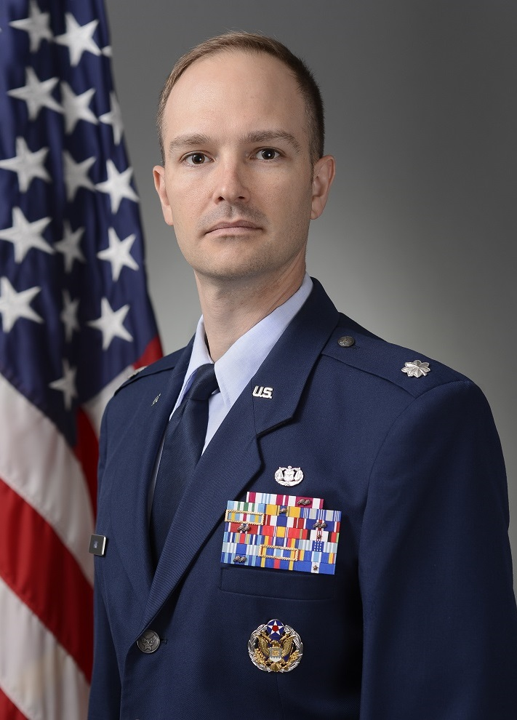
Lt Col Matt King is the Chief, Air and Space Law at the Headquarters Air Force Operations and International Law Directorate (AF/JAO). He previously served as an Appellate Defense Counsel, representing clients before the AF Court of Criminal Appeals, Court of Appeals for the Armed Forces, and United States Supreme Court; Deputy Staff Judge Advocate at Little Rock AFB, supporting two wing commanders and subordinate units under three MAJCOMs; Assistant Professor of Law at the US Air Force Academy, teaching LOAC, Advanced LOAC, International Law, and Law for Air Force Officers, and serving as the Department of Law and Division of Social Sciences Executive Officer; managing Area Defense Counsel at Ramstein AB, Germany; Assistant Chief of Military Justice at Ramstein AB; and Assistant Staff Judge Advocate at Sheppard AFB, Texas. Lt Col King has deployed as the Deputy Legal Advisor (LEGAD) to the AFCENT Combined Air Operations Center (CAOC) at Al Udeid AB, Qatar; LEGAD to the NATO Commander of Kandahar Airfield, Afghanistan (COMKAF); and as deputy LEGAD to the NATO Headquarters in Sarajevo, Bosnia-Herzegovina (NHQ-Sa).

Lt Col King was commissioned through the Direct Appointment Program in January 2003 and attended JASOC from February to April 2003. He is admitted to practice law before the United States Supreme Court, the Supreme Court of Pennsylvania and the Court of Appeals for the Armed Forces. Lt Col King and his wife have a daughter and a son.

EDUCATION

1999 B.A., with Distinction, in History and Foreign Affairs, University of Virginia, Charlottesville, VA
2002 J.D., magna cum laude, University of Pittsburgh School of Law, Pittsburgh, PA; Certificate in International and Comparative Law

2007 Squadron Officer School, Top Third Graduate, Maxwell AFB, AL (in residence)

2013 Air Command & Staff College (by correspondence)

2016 LL.M. in Air and Space Law, McGill University, Montreal, QC, Canada

2017 Air War College (by correspondence)

ASSIGNMENTS

- April 2003 – August 2005, Assistant Staff Judge Advocate (Chief, Legal Assistance and Preventive Law; Chief, Administrative Discharges and Demotions; Military Justice Attorney), 82d Training Wing, Sheppard AFB, TX
- August 2005 – October 2006, Assistant Staff Judge Advocate (Assistant Chief of Military Justice), 435th Air Base Wing, Ramstein AB, Germany
(May 2006 – September 2006, Deputy Legal Advisor, NATO HQ, Sarajevo, Bosnia-Herzegovina)
- November 2006 – June 2008, Area Defense Counsel, Ramstein AB, Germany
- June 2008 – September 2010, Assistant Professor of Law and Executive Officer (June 2009 to June 2010), US Air Force Academy, Colorado Springs, CO
- September 2010 – July 2012, Deputy Staff Judge Advocate, 19th Airlift Wing, Little Rock AFB, AR
(November 2011 – June 2012, Legal Advisor, NATO HQ, Commander Kandahar Airfield, Afghanistan (COMKAF))
- July 2012 – August 2014, Appellate Defense Counsel, AFLOA/JAJA, JB Andrews, MD
- August 2014 – August 2015, AFIT Student, McGill University, Montreal, QC, Canada
- August 2015 – present, Air Staff Attorney (Chief, Air and Space; Chief, Operations and Cyber; Chief, Readiness, Training, and Contingency Planning), HQ AF/JAO, Pentagon, Washington D.C.
(January 2017 – July 2017, Deputy Legal Advisor, Combat Plans Division, AFCENT Combined Air Operations Center, Al Udeid AB, Qatar)

MAJOR AWARDS AND DECORATIONS

Defense Meritorious Service Medal
Meritorious Service Medal with oak leaf clusters
Joint Service Commendation Medal
AF Commendation Medal with oak leaf cluster
AF Achievement Medal
Joint Meritorious Unit Award
Meritorious Unit Award
AF Outstanding Unit Award with oak leaf clusters
AF Organizational Excellence Award with oak leaf clusters
Afghanistan Campaign Medal
Global War on Terror Expeditionary Medal
AF Expeditionary Service Ribbon with Gold Border
AF Expeditionary Service Ribbon
NATO non-Article V Medal with device (Balkans and ISAF)

Awarded the Professor Masao Sekiguchi Fellowship in Air and Space Law, McGill University Faculty of Law

EFFECTIVE DATES OF PROMOTION

First Lieutenant 5 January 2003
Captain 5 July 2003
Major 1 February 2010
Lieutenant Colonel 1 June 2015

MAJOR publications

Sovereignty’s Gray Area: The Delimitation of Air and Space in the Context of Aerospace Vehicles and the Use of Force, 81 J. Air L. & Com. 377 (2016)

Security, Scale, Form, and Function: The Search for Truth and the Exclusion of Evidence in Adversarial and Inquisitorial Justice Systems, 12 Int’l Legal Persp. 185 (2002)

Towards a Practical Convergence: The Dynamic Uses of Judicial Advice in United States Federal Courts and the Court of Justice of the European Communities, 63 U. Pitt. L. Rev. 703 (2002)

(Current as of December 2017)

