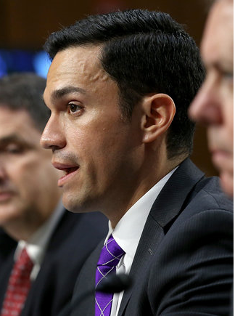
Carlos Uriarte currently serves as Associate Deputy Attorney General at the Department of Justice. He was previously Senior Counsel in the Office of the Secretary at the Department of the Interior. At Interior, Mr. Uriarte managed the Department's responses to Congressional oversight requests and investigations by the Department's Inspector General. Previously, Mr. Uriarte served as Minority Counsel on the House Oversight Committee where he led a team focused on national security investigations. He has also worked for Congresswoman Judy Chu, covering her assignment to the House Judiciary Committee. Before moving to the Government, Mr. Uriarte worked at Crowell & Moring and Akin Gump Strauss Hauer & Feld LLP in Washington, D.C., and clerked for the Honorable Juan R. Sanchez of the Eastern District of Pennsylvania. Mr. Uriarte is a graduate of Washington University in St. Louis and the University of Pennsylvania Law School.

